        - SmartMedia Interface Error Correction
The SmartMedia interface supports hardware error detection. During read and write, hardware error correction code (ECC) calculation is performed every 256-bytes. The generated ECC can be read from ECC1CP (0x14), ECC1LP (0x15), ECC2CP (0x16), and ECC2LP (0x17). ECC1CP and ECC1LP are used for Storing Area -1 and ECC2CP and ECC2LP are used for Storing Area -2.
When the page size is configured to 256 + 8 bytes per page, Storing Area –1 corresponds to bytes 0-255 of the even numbered pages, and Storing Area – 2 corresponds to bytes 0-255 of odd numbered pages.
When the page size is configure to 512 + 16 bytes per page, Storing Area – 1 corresponds to bytes 0-255 and Storing Area – 2 corresponds to bytes 256-511.
Although the hardware caluculates ECC, the ARM software must perform ECC data comparison and correction. If 512+16 byte page SmartMedia is used, the calculated ECC is stored at ECC1CP and ECC1LP after the first half (256 bytes) of data is read, and then ECC2CP and ECC2LP are updated after the second half (256-bytes) of data is read. The procedure in the case where smart media is used is shown below.
512+16bytes/page mode
- Write “1” to ECLR in ECCCLR (0x18) to clear the previous ECC results.
- Read or Write the first half (0-255) of data -> ECC1CP & ECC1LP is updated.
- Read or Write the second half (256-511) of data -> ECC2CP & ECC2LP is updated.
- Check the ECC stored at ECC1CP, ECC1LP, ECC2CP and ECC2LP
- Write “1” to ECLR in ECCCLR (0x18) to clear the ECC for the next page access.
256+8bytes/page mode
- Write “1” to ECLR in ECCCLR (0x18) to clear the previous ECC results.
- Read or Write the data area (0-255) of Even-numbered page -> ECC1CP & ECC1LP is updated.
- Read or Write the data area (0-255) of Odd-numbered page -> ECC2CP & ECC2LP is updated.
- Check the ECC stored at ECC1CP, ECC1LP, ECC2CP and ECC2LP
- Write “1” to ECLR in ECCCLR (0x18) to clear the ECC for the next pair of pages.

“Error Detection & Correction” can be performed by comparing the calculated ECC (ECC1CP, ECC1LP, ECC2CP and ECC2LP) and the ECC stored at the redundant area of the page.

- ECC Area 1 CP Register Diagram

- ECC Area 1 CP Register Bit Summary

- ECC Area 1 LP Register Diagram
- ECC Area 1 LP Register Bit Summary

- ECC Area 2 CP Register Diagram
- ECC Area 2 CP Register Bit Summary
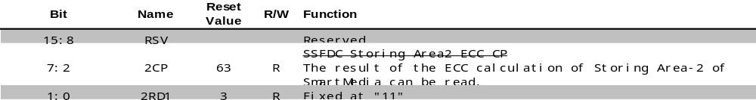

- ECC Area 2 LP Register Diagram

- ECC Area 2 LP Register Bit Summary

- ECC Clear Register Diagram
- ECC Clear Register Bit Summary

